User Manual Specification
Release Version -1.1
For
Meghna Solar Ltd.
Concern Topic: Global Configuration

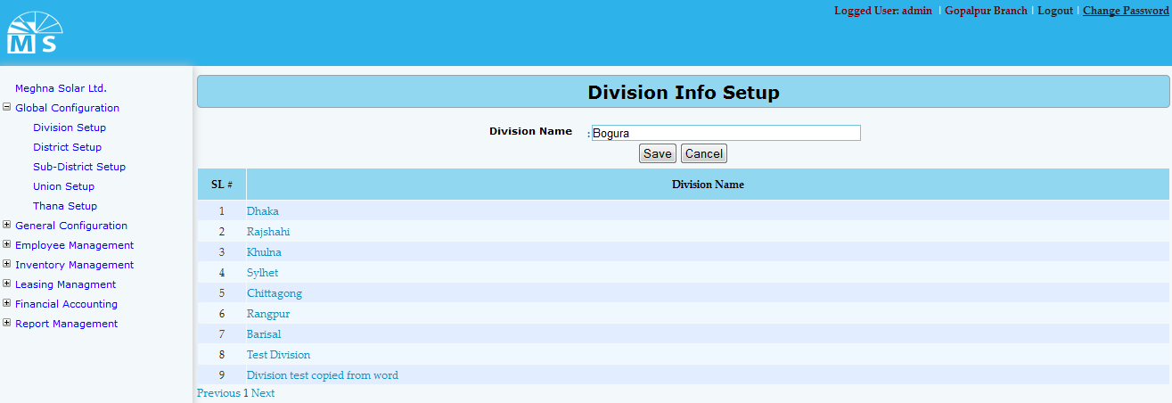

Division Info Setup

Here user needs to enter Division Name in the text box and click Save Button to save the Division. Recently saved Divisions will be visible in the below grid view. For updating any Division user need to click on the Division name in the grid view. Then after modifying the division info in the text box like the below picture, user need to Press Update button. After this, modified division name can be seen in the grid view. User can also delete the Division name here.

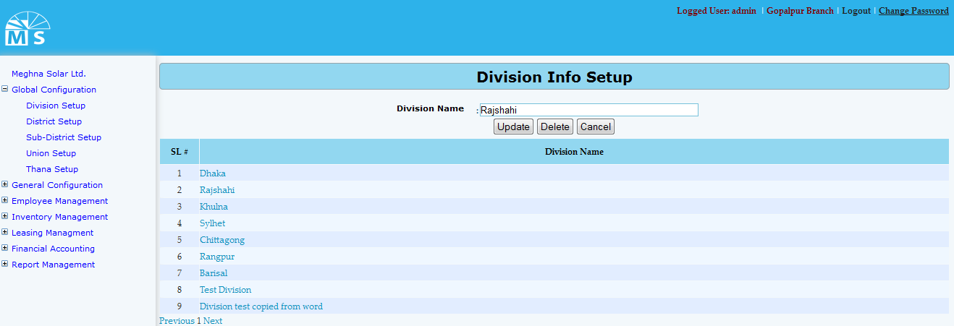

Division Info Update

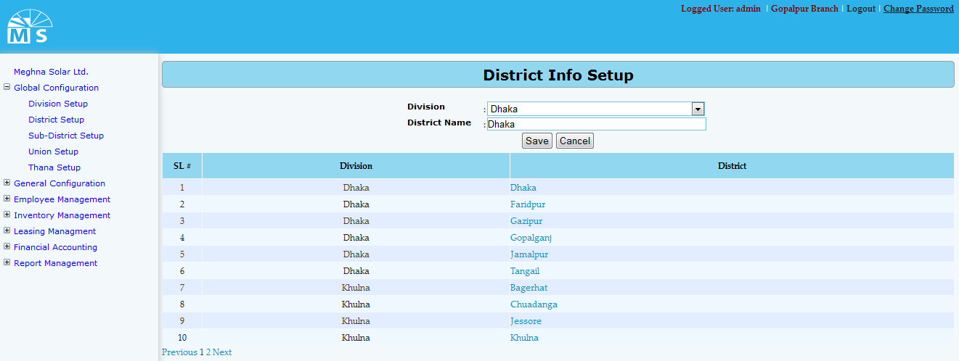

District Info Setup

Here user needs to select Division name from the division dropdown list. Then enter District Name under that Dvision in the text box and click Save Button to save the District. Recently saved District will be visible in the below grid view. For updating any District user need to click on the District name in the grid view. Then after modifying the Division and District info in the text box, user need to Press Update button. After this, modified District name can be seen in the grid view.

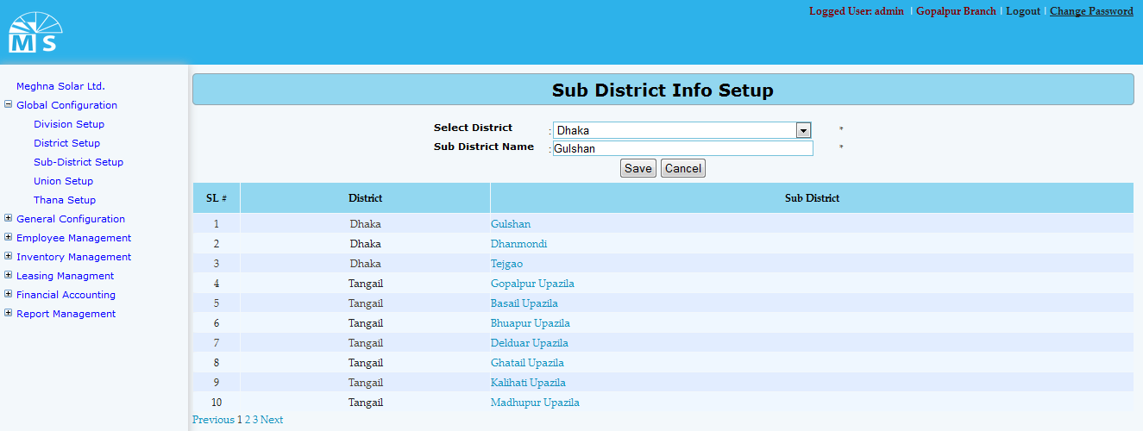

Sub District Info Setup

Here user needs to select District name from the District dropdown list. Then enter Sub District Name under that District in the text box and click Save Button to save the Sub District. Recently saved Sub District will be visible in the below grid view. For updating any Sub District user need to click on the Sub District name in the grid view. Then after modifying the District and Sub District info in the text box, user need to Press Update button. After this, modified Sub District name can be seen in the grid view.
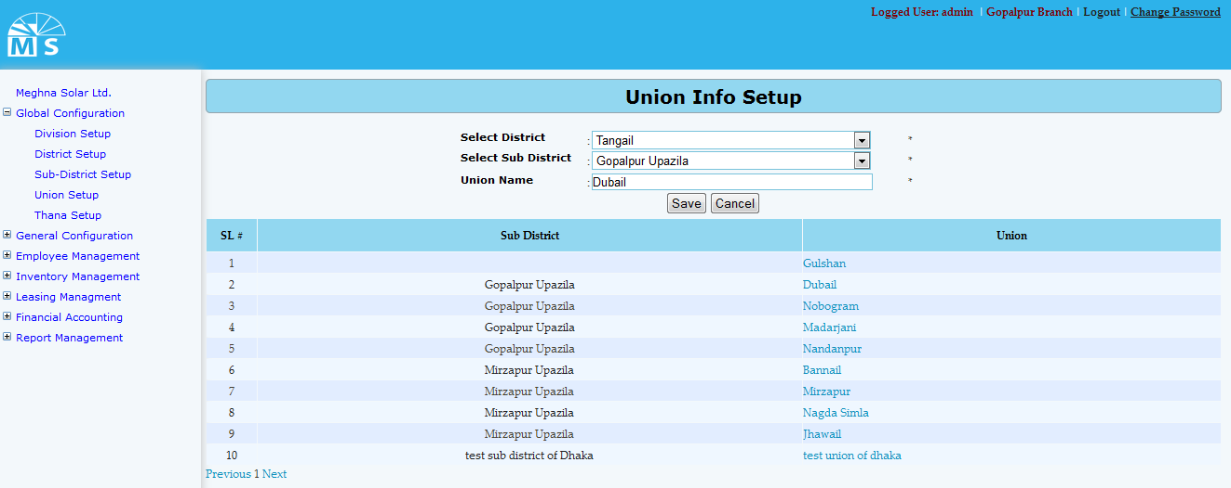

Union Info Setup
Here user needs to select District name and Sub District name from the following dropdown list. Then enter Union Name under that District and Sub District in the text box and click Save Button to save the Union. Recently saved Union will be visible in the below grid view. For updating any Sub District user need to click on the Union name in the grid view. Then after modifying the District, Sub District and Union info in the text box, user need to Press Update button. After this, modified Union information can be seen in the grid view.

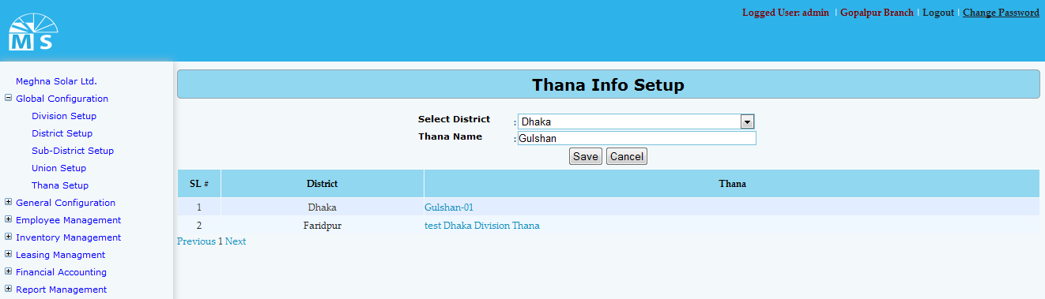

Thana Info Setup

Here user needs to select District name from the following dropdown list. Then enter Thana Name under that District in the text box and click Save Button to save the Thana. Recently saved Thana will be visible in the below grid view. For updating any Thana user need to click on the Thana name in the grid view. Then after modifying the District and Thana info in the text box, user need to Press Update button. After this, modified Thana information can be seen in the grid view.

